|  |  |
| --- | --- |
| Date | 18 October 2022 |
| Team ID | PNT2022TMID42059 |
| Project Name | AI based localization and classification of skin disease with Erythema |
| Maximum Marks | 8 Marks |

**SPRINT DELIVERY PLAN**

**Introduction:**

Erythema is a broad category of skin condition that can impact any area of the skin and mucous membranes. It usually occurs in response to disease or infection in reaction to a drug. Severity of the rash ranges from mild to life threatening.

**What Is Erythema?**

Erythema is an abnormal redness of skin or mucous membranes.

Capillary congestion causes the condition, and red splotches on the hands or feet are classic examples of it.

People often mistake erythema for common skin inflammation or psoriasis because it has similar characteristics: redness, rashes, swelling and skin sensitivity.

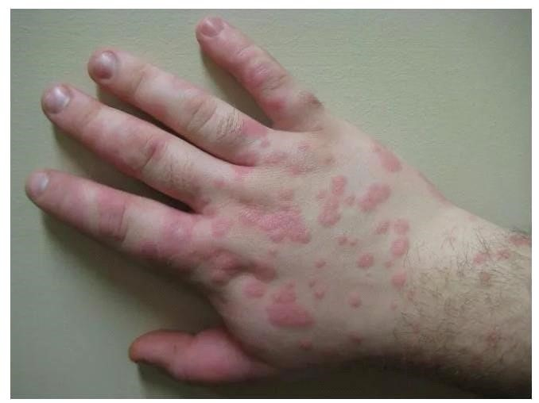

**Erythema Multiforme:**

Erythema multiforme (EM) is the most common type of erythema. Its cause is thought to be IgM immune complexes deposited in the skin, often as a result of viral or bacterial infections, such as herpes simplex virus (HSV) type 1 and 2 and Mycoplasma pneumoniae infections. More rarely, it can be a reaction to a drug or vaccine, according to the National Library of Medicine.

The condition can affect both men and women, although men are five times more likely to develop it compared to women. Most people who get EM are between 20 and 30 years old, although 20% of those diagnosed are children.

**Types:**

There are two types of EM, minor and major.

Erythema multiforme minor (EM minor) typically occurs on the peripheral parts of the body, such as the fingers and toes. Rarely, it may manifest as light mouth sores. It usually clears up on its own.

Erythema multiforme major (EM major) skin lesions are more extensive and serious. Raised, edematous papules covering more than 10% of the body with involvement of at least one mucous membrane characterizes the condition. A drug reaction is a more likely cause than an infection. Similarly, medication also causes Stevens-Johnson Syndrome, a potentially life-threatening skin rash.

Unlike EM minor, EM major causes extensive blistering sores on one or more of the body’s mucous membranes, such as the lips or mouth.. They can also appear on the eyes or anus. If you are experiencing irritation or what appears to be blistering on one of these areas of your body.

**Symptoms:**

Most people with EM develop a sudden small rash that usually begins on their feet or hands and spreads to the upper limbs, face and upper body. It starts with small red spots that grow larger and form what looks to be a bull’s-eye, darker in the middle with a lighter outer ring.

**EM symptoms include:**

* Circular red bumps on the soles, palms, arms, face and legs that grow into circles that may look like targets.
* Itchiness, in some cases.
* Painful sores or blisters on the lips, mouth, eyes and genitals.
* Red patches with pale rings inside the patch with purple centers and small blisters, called target lesions.
* Fever.
* Joint pain.
* Sensitivity to light.

**First Stage Plan:**

It is the phase when erythema can be seen within a few hours of irradiation (although it is extremely rare with radiological interventional procedures). This early phase of erythema is generally transient, subsiding after 24 - 48 hours, but it may persist and evolve, ‘blending’ with the subsequent phases. Whether or not those early changes are of importance and influence the subsequent course of the skin reaction remains a matter of debate. However, it is generally considered that early erythema does not necessarily predict a particular severity of the later phases.

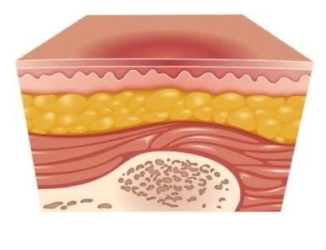

**Second Stage Plan:**

This corresponds clinically to a more severe reddening of the skin, and is usually associated with inflammatory reactions. It starts about two to three weeks after exposure. It may be painful (as a burn). Within a short time it may become associated with various degrees of skin desquamation, and possibly with pigmentation. Skin lesions that up to now were not very painful can become painful at this stage. These pains can be very severe when the irradiated volume was large. An important point here is that moist desquamation, which implies a total destruction of the epidermis, is a clear predictor of late delayed injuries, particularly telangiectasias.

The early phase of erythema is usually not detectable in dark skinned people; in the second "main" phase, it is generally hyperpigmentation that is observed.

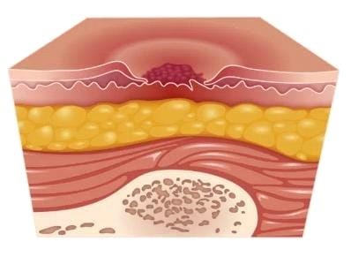

**Third Stage Plan:**

Classically, a third phase of erythema can be observed later, between 8 to 20 weeks after irradiation. This phase is associated with dermal ischemia and may also evolve towards necrosis.

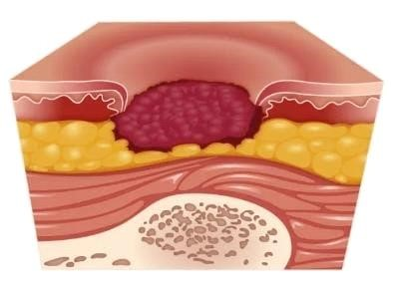

**Fourth Stage Plan:**

Evolution: If severe, skin reactions can be responsible for late radiodermatitis. Increased pigmentation is usual, but depigmentation can also be observed (usually at higher doses), with a combination of both being observed in some cases. The skin may also become hyperkeratotic.

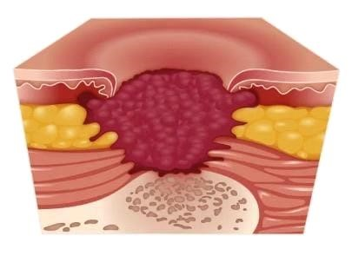

**Fifth Stage Plan:**

Reactivation: As could be expected, sunburn is likely to exacerbate any radiation-induced erythema reaction. A few drugs are also capable of increasing erythema linked to radiation exposure; this is particularly true for some antineoplastic agents, such as Bleomycin, Adriamycin and the Taxanes drugs. Interestingly, after erythema subsides, it can be reactivated (i.e re-appearance of erythema in the same area) if the drug is given a few days or weeks later.

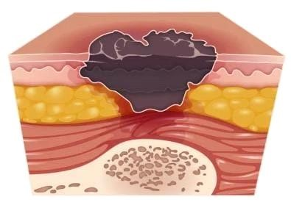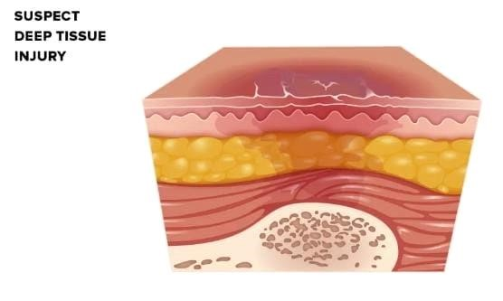

**TREATMENT:**

The treatment for erythema multiforme depends on the subtype. EM minor usually goes away on its own, but if symptoms persist, a doctor might recommend topical steroids. If EM minor symptoms recur because of a suspected herpes flare-up, doctors may prescribe antiviral medications such as acyclovir or valacyclovir.

The presence of EM can also be a sign of a more serious condition or a compromise of the immune system. When your doctor examines you, they may choose to recommend additional testing.

Those diagnosed with EM major may require more care. Aside from steroids, eye drops and mouthwashes with topical anesthetics, they may need to be admitted to a hospital for IV fluids.